Ball bearing fault prediction using SVM/NTK

Waibhav Jha  
*Amrita School of Artificial Intelligence*  
*Amrita Vishwa Vidyapeetham*Coimbatore, India  
[waibhavj@gmail.com](mailto:waibhavj@gmail.com)

Ambika P.S

*Amrita School of Artificial Intelligence*  
 *Amrita Vishwa Vidyapeetham*Coimbatore, India  
ambika[@cb.amrita.edu](mailto:g_kriteshkumar@cb.amrita.edu)

Akash bardia  
*Amrita School of Artificial Intelligence*  
*Amrita Vishwa Vidyapeetham*Coimbatore, India  
[akashbardia2005@gmail.com](mailto:akashbardia2005@gmail.com)

***Abstract*—This study explores the use of Support Vector Machines (SVM) with Neural Tangent Kernel (NTK) for predicting faults in ball bearings. Ball bearing failures can cause significant operational issues, and traditional fault detection methods often fall short due to data complexity. By leveraging NTK, which models the behavior of infinitely wide neural networks, we provide a robust kernel for SVM. We preprocess vibration signal data, split it into training and testing sets, and compute the NTK using a neural network architecture. A randomized search with cross-validation is used to optimize SVM hyperparameters. The final model is evaluated on the test set using accuracy, F1 score, and confusion matrix. Results show that SVM with NTK outperforms traditional SVM models, achieving high accuracy and precise fault classification. This approach combines neural networks' feature extraction with SVM's classification performance, offering a robust solution for predictive maintenance in ball bearings.**

***Keywords: Ball bearing failures, Machine Learning, Support Vector Machines, Neural Tangent Kernel, Classification.***

1. INTRODUCTION

Ball bearings are vital in reducing friction and wear in mechanical systems, directly affecting machinery efficiency and lifespan. Accurate fault prediction is crucial to avoid failures, reduce downtime, and ensure safety. Faults in ball bearings can result from manufacturing defects, improper installation, insufficient lubrication, or wear and tear, reflected in changes in vibration signals. Advanced techniques like machine learning and signal processing analyze these signals to detect anomalies and predict failures, enhancing reliability and operational efficiency.

[1] discusses the development of an online bearing fault diagnosis method that combines numerical simulation models with machine learning classification. The purpose of this paper is to enhance the efficiency and accuracy of bearing fault detection. The approach creates a numerical simulation model to generate vibration signals corresponding to faults in the bearing. These signals train the machine learning model. Experimental results show that the model predicts the ball bearing faults with high accuracy. This combination of numerical simulation models and machine learning classification provides a robust and effective approach for bearing fault analysis.[2] uses a deep learning model for bearing fault diagnosis on the CWRU dataset. It employs a reduced-layer convolutional neural network architecture. The model predicts the faults with high accuracy and outperforms traditional methods, making it suitable for real-time fault detection applications. The study demonstrates the use of deep learning algorithms for efficient and accurate fault prediction in bearings.[3] discusses the characteristics of bearing vibrations using a machine learning model. This study used a long short-term memory (LSTM) neural network to analyze the vibration signals and predict any faults in the bearing. The results show high accuracy and demonstrate the robustness of machine learning models in predicting bearing faults.[4] introduces a new hybrid method that uses deep learning techniques and signal processing algorithms to increase model accuracy. This model first pre-processes the data, then extracts relevant features using deep convolutional neural networks, and finally employs a machine learning model such as long short-term memory (LSTM) for fault classification. This highlights the potential of using a hybrid approach of deep learning and signal processing for more accurate results.[5] combines kurtogram analysis and deep learning sequence models. Kurtogram is a fourth-order spectral tool for detecting and characterizing non-stationarities in a signal. This paper shows the robustness of combining kurtogram with deep learning algorithms, which enables proactive maintenance strategies in industrial systems.[6] proposes a method that uses the generalized demodulation (GD) algorithm, which transforms the instantaneous frequency trajectory of compound fault signals, allowing direct fast Fourier transform without angular resampling. Detecting multiple faults in rolling element bearings under variable rotational speeds is complex due to speed fluctuations and fault interactions. This paper discusses the accuracy of the model using generalized demodulation.[7] depicts the fault predictions of ball bearings using machine learning algorithms such as support vector machines and random forests to classify different types of faults based on various vibration signals. Features are extracted from the dataset and used as input signals for the model. This depicts the effectiveness of machine learning models.[8] talks about the detection of faults in ball bearings in induction motors by utilizing vibration signals and machine learning techniques. The model extracts relevant features from vibrational signals, such as statistical features and wavelet-based features. These features are used to train models such as support vector machines and artificial neural networks.

The concise literature review presented in the preceding paragraphs highlights the importance of advanced techniques in bearing fault diagnosis. Specifically, it emphasizes the role of machine learning models, such as support vector machines (SVM) and neural network techniques (NTK), in accurately predicting faults based on vibration signals.

1. METHODOLOGY

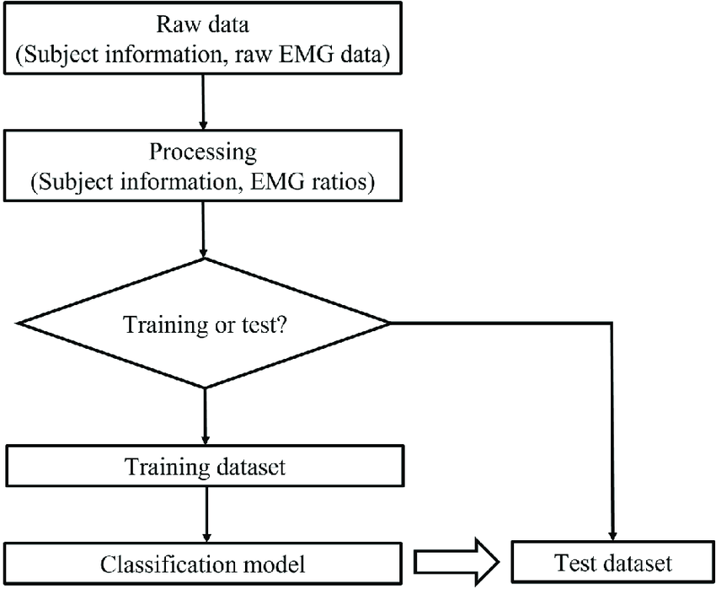

Fig1: Methodology flowchart for Classification problem

The dataset selected in the present study is sources from Kaggle provided by Case Western Bearing Data Center.

This dataset corresponds to these 3 specific pre-requisites:

* A load of 1HP is applied to the motor.
* The shaft rotates at a speed of 1772 RPM.
* The Accelerometers sample at a frequency of 48kHz

Nine features have been extracted for fault prediction: mean, standard deviation, RMS, skewness, kurtosis, crest factor, maximum, minimum, and form factor. Each feature is computed for time segments of 2048 points, corresponding to 0.04 seconds at the 48kHz accelerometer sampling frequency.

SUPPORT VECTOR MACHINES:

A support vector machine (SVM) is a supervised learning algorithm primarily used for classification tasks. It finds the hyperplane that maximizes the margin between different classes in an N-dimensional space. SVMs can handle both linear and non-linear classification. For non-linear cases, kernel functions like linear, polynomial, RBF, and sigmoid transform the data into higher dimensions, enabling linear separation - a technique known as the "kernel trick." In our case, we utilized linear and RBF kernels.

Linear SVMs are used for linearly separable data, represented mathematically as

*wx+b=0*

In the given equation, w stands for the weight vector, x for the input vector, and b as the bias term.

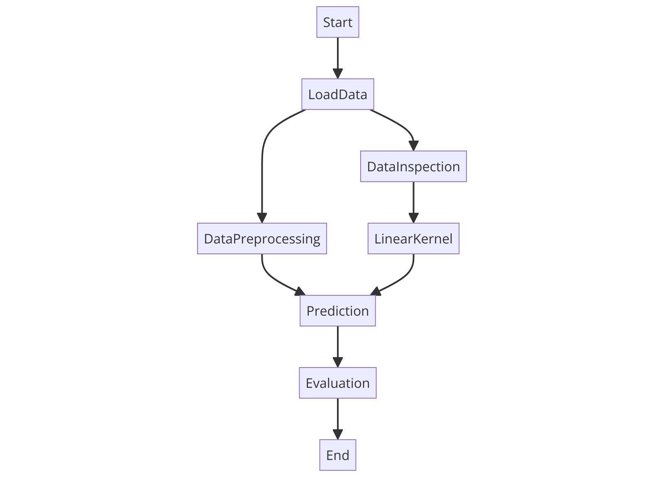

Fig 2: Flowchart for methodology of linear kernel in SVM

The RBF kernel is used when data is not linearly separable. It calculates the similarity between two points, X₁ and X₂​, using the following formula:



Here, σ is the variance and a hyperparameter, while ||X₁ - X₂|| represents the Euclidean (L2-norm) distance between X₁ and X₂

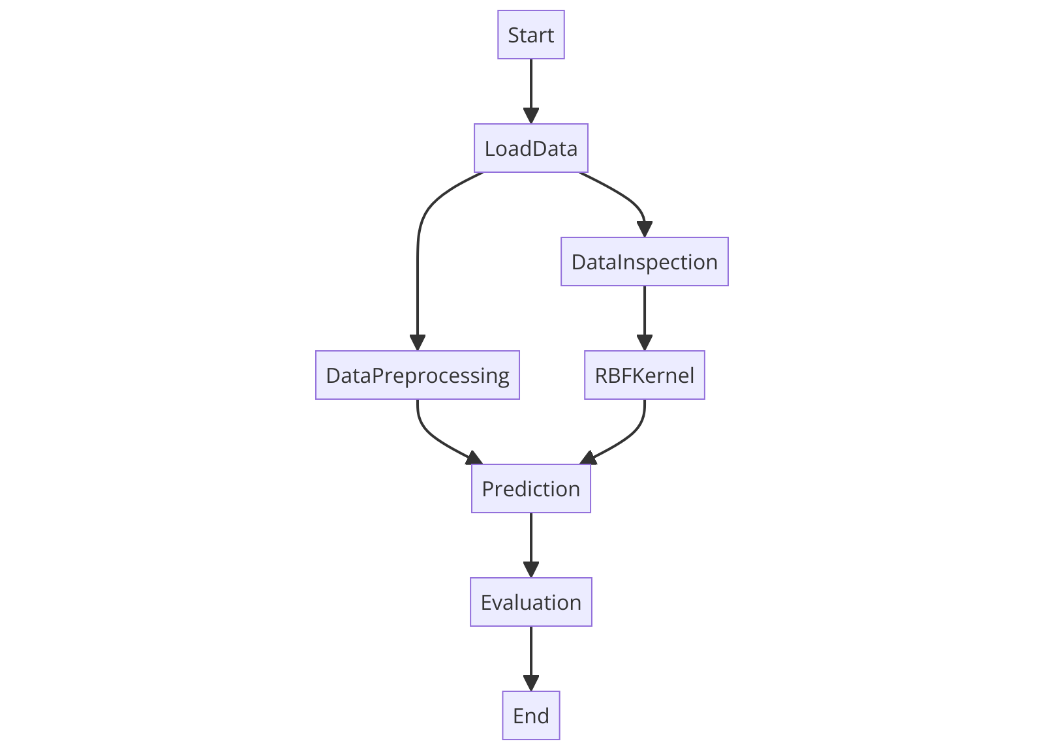

Fig 3: Flowchart for methodology of RBF kernel

We mainly employ these 2 kernel tricks to find the best results for our data. We then go on to apply hyperparametric tuning using 5-fold cross validation. We do so to find out which parameters give the most optimized results for our data. We divide the dataset into 5 folds of equal or almost equal parts and take 4 folds for training and 1-fold for cross validation, giving us the best results for our model.

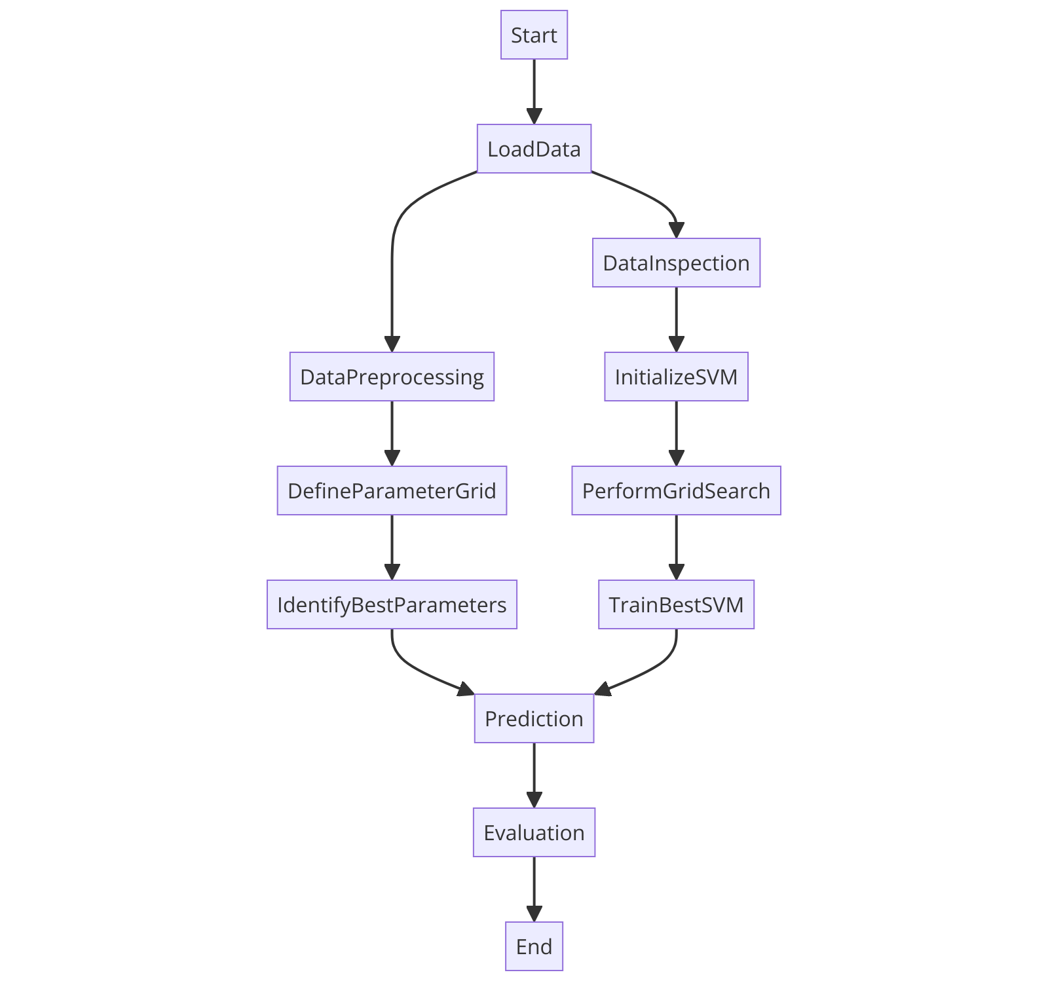

Fig 4: flowchart for 5-fold cross validation

NEURAL TANGENT KERNEL:

The Neural Tangent Kernel (NTK) explains neural networks' training dynamics using gradient descent. It elucidates why sufficiently wide neural networks converge to a global minimum when minimizing empirical loss. In our study, we compute NTK using a complex architecture with multiple dense and ReLU layers, followed by an output layer. We calculate NTK for both training and testing data to obtain kernel matrices. Using NTK as a precomputed kernel, we employ it in an SVM classifier, optimizing hyperparameters through randomized search with cross-validation to find the best regularization parameter C.

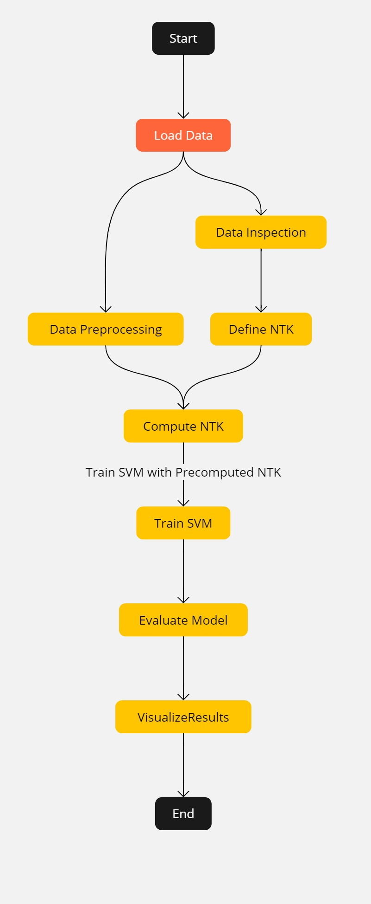

Fig 5: flowchart for methodology for NTK

1. RESULTS AND DISCUSSION

These sections present the results and discussion from the obtained classification task. We have obtained a confusion matrix which contains 10 unique classes as per the fault column which happens to be our target variable for the model. The confusion matrix plots the True positive, False positive, True negative and False Negative rates of the classes taken for the classification problem.

LINEAR KERNEL SVM:

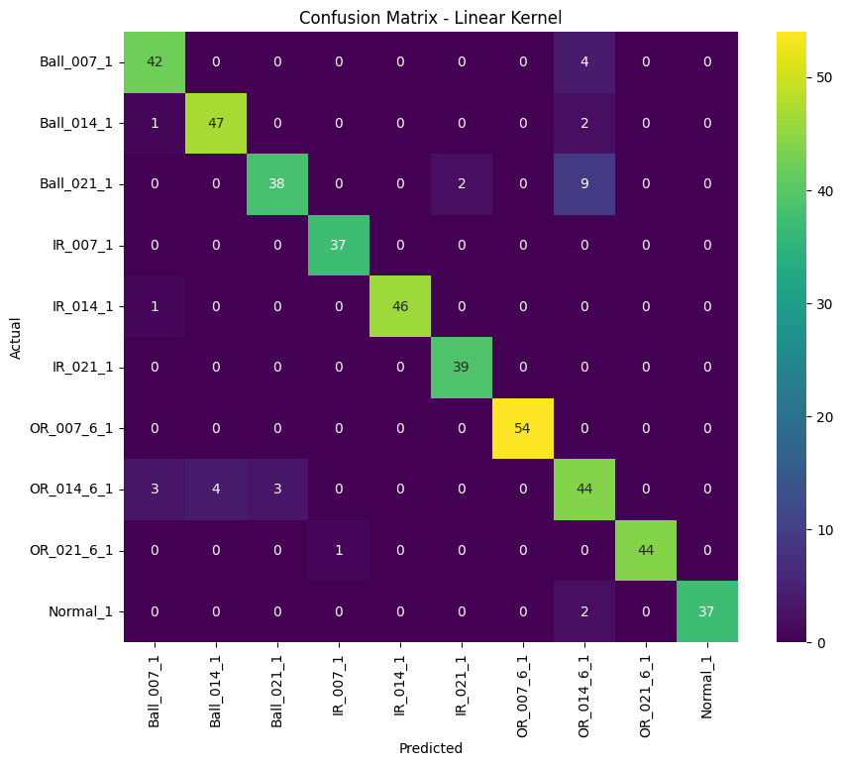

Fig 6: Confusion-Matrix for Linear-kernel SVM

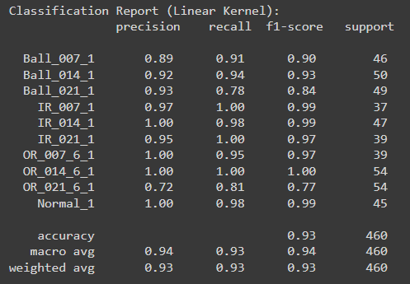

Fig 7: Classification-report for Linear-kernel SVM

The high precision and f1-score for the linear kernel denotes that our data is mainly a linearly seperable data making it a fit for linear kernel. Our model works fairly well for this data giving us a precision of 94% and an f1 score of 93%, showing that the model is well fit for the prediction task

RBF-KERNEL SVM:

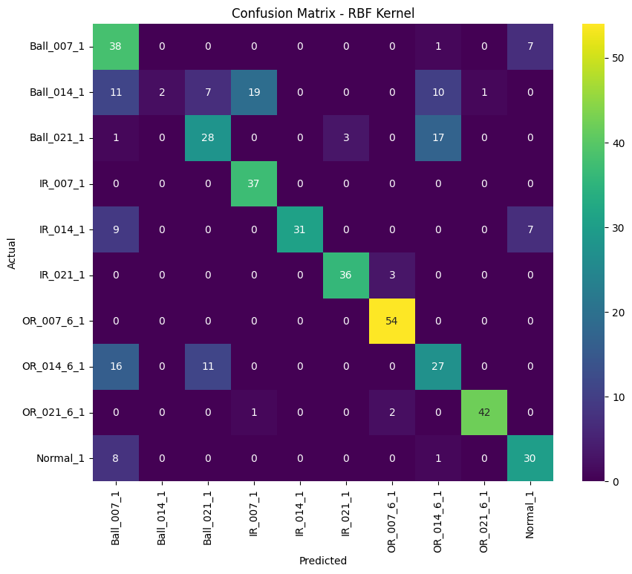

Fig 8: Confusion-matrix for RBF-kernel

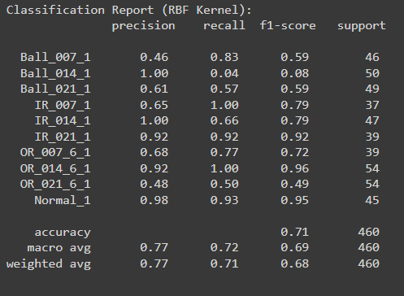

Fig 9: Classification-report for RBF-kernel

From the confusion matrix and classification report that there are varying differences between the true and false positive rates for the RBF kernel showing that it only gives us average predictions for the data. It has an F1-score of 71% and an precision of 77% making it a less ideal choice for this data compared to the linear kernel

THE 5-FOLD CROSS VALIDATION:



Fig 10: Confusion-matrix for 5-fold CV

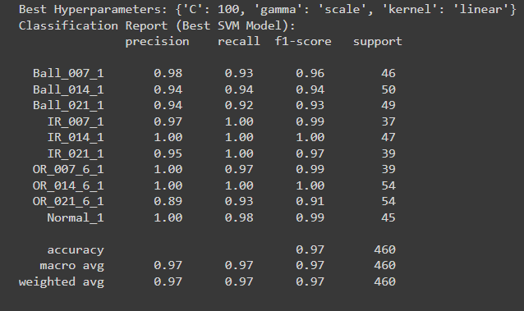

Fig 11: Classification-report for 5-fold CV

From the confusion matrix and classification report, we can conclude that the model is well tuned to the dataset giving us high precision and F1-Scores. The confusion matrix denotes very minimal misclassifications, highlighting the model’s accuracy in fault classification.

With the best parameters identified (C: 100, gamma: 'scale', kernel: 'linear'), the model depicts an overall accuracy of 97% solidifying the effectiveness of this model.

THE PRECOMPUTED NEURAL TANGENT KERNEL(NTK)-SVM:

Fig 12: Confusion-matrix for NTK as a precomputed kernel in SVM

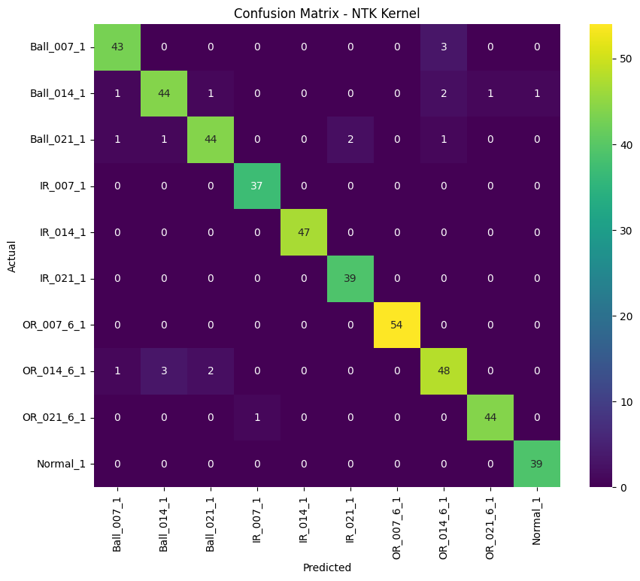

Fig 13: Classification-Report for NTK as a precomputed kernel in SVM

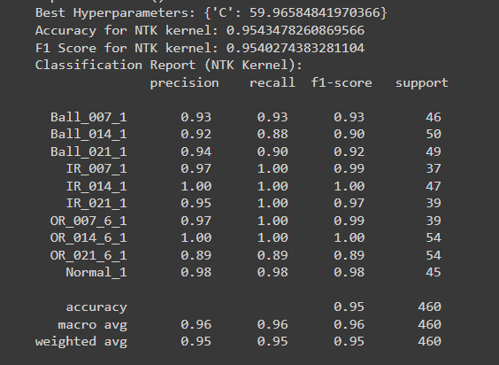

From the confusion matrix and classification report, we can conclude that the NTK-SVM model is highly tuned to the dataset, providing high precision and F1-scores. The confusion matrix shows very minimal misclassifications, underscoring the model’s accuracy in fault classification. With the best parameters identified (C: 59.97), the model achieves an overall accuracy of 95.34%, solidifying its effectiveness for bearing fault detection tasks. This consistent performance across all classes highlights the robustness and reliability of the NTK-SVM model in predicting bearing faults accurately.

1. CONCLUSION

In this paper we have presented the use of Support vector machine and neural tangent kernel for predicting faults in ball bearings. The aim was to explore the effectiveness and robustness of such machine learning algorithms, which has proven to be of adequate accuracy.

According to our study we have found both SVM and NTK a strong model for fault detection and are advantageous. SVM is able to handle high-dimensional data and classifies the data with high accuracy, whereas, NTK with its deep neural networks can capture complex patterns. The combination of these two has proved to be well suited for our dataset and can act as a good base for future advancements in this field.

1. REFERENCES
2. Wang, H., Zheng, J., & Xiang, J. (2023). Development of an online bearing fault diagnosis method combining numerical simulation models with machine learning classification.
3. Yoo, Y., Jo, H., & Ban, S. W. (2023). Bearing fault diagnosis using a deep learning model on the CWRU dataset.
4. Salunkhe, V. G., & Desavale, R. G. (2021). Characteristics of bearing vibrations using an LSTM neural network.
5. He, M., & He, D. (2020). A hybrid method for bearing fault classification using deep learning and signal processing.
6. Udmale, S. S., Singh, S. K., & Bhirud, S. G. (2019). Combining kurtogram analysis with deep learning for bearing fault detection.
7. Zhao, D., Li, J., Cheng, W., & Wen, W. (2016). Generalized demodulation for rolling element bearing fault detection.
8. Kankar, P. K., Sharma, S. C., & Harsha, S. P. (2011). Fault predictions in ball bearings using SVM and random forests.
9. Irgat, E., Çınar, E., & Ünsal, A. (2021). Fault detection in ball bearings of induction motors using machine learning.